CSA6303 - THREAT INTELLIGENCE AND NETWORK SECUR

Assessment Tool 1: CONCEPT MAPPING
Faculty : Dr.V.Parthipan SLOT A

Topics: Network Security Fundamentals | Security Goals (CIA Triad) | Types of Network Threats
|Introduction to Threat Intelligence Types of Threat Intelligence (Strategic, Tactical, perational) — Threat Intelligence Lifecycle — Applications in IT Industry

CO1: Interpret security principles, network threats, and the role of threat intelligence in cybersecurity.

Total: 50
Student Name : N. Meghana Register number: 192411129

Code of Conduct:

I N. Meghana (192411129) certify that this submission is my original work and that I have adhered to the guidelines specified for this assessment. I understand that any violation of academic integrity rules will result in disciplinary action.

Signature of the student: N. Meghana

CO1 – Concept Mapping Questions

No. | Concept-Mapping Question
1 | Construct a comprehensive concept map explaining the foundations of Network Security. Connect network security fundamentals with security objectives, the CIA Triad (Confidentiality, Integrity, and Availability), network assets, vulnerabilities, threats, and protective measures, and explain how these concepts collectively support secure network operations.
2 | Develop a concept map illustrating the CIA Triad as the foundation of network security. Relate Confidentiality, Integrity, and Availability to different types of network threats and demonstrate how a single threat can affect one or more security goals.
3 | Construct a concept map classifying different types of Network Threats and their potential impact on security goals. Connect threats such as malware, phishing, denial-of-service, spoofing, eavesdropping, and unauthorized access with the CIA Triad and explain the resulting security implications.
4 | Develop an integrated concept map connecting Network Security Fundamentals, Network Threats, and Threat Intelligence. Show how identifying assets, vulnerabilities, and threats leads to the collection and analysis of threat information and ultimately  supports informed security decisions.
5 | Construct a concept map explaining the concept of Threat Intelligence and its role in modern network security. Relate threat actors, indicators, vulnerabilities, attack patterns, threat information, analysis, and actionable intelligence to demonstrate how Threat  Intelligence helps organizations anticipate and respond to network threats.
6 | Develop a comparative concept map of Strategic, Tactical, and Operational Threat Intelligence. Connect each type with its purpose, target audience, time horizon, information requirements, decision-making process, and appropriate network-security use cases, and analyze how the three intelligence types complement one another.
7 | Construct a concept map representing the complete Threat Intelligence Lifecycle. Connect planning/direction, collection, processing, analysis, dissemination, and feedback with the identification of network threats and security requirements, showing how feedback continuously improves the intelligence process.
8 | Develop an end-to-end concept map showing how a network threat progresses from identification to actionable Threat Intelligence. Connect network security fundamentals, CIA security goals, threat detection, intelligence collection, processing, analysis, dissemination, and response, and explain the relationship between each stage.
9 | Create a scenario-based concept map for an organization experiencing a major network attack. Integrate the CIA Triad, types of network threats, Strategic Intelligence,  Tactical Intelligence, Operational Intelligence, and the Threat Intelligence Lifecycle to demonstrate how the organization can understand, prioritize, and respond to the threat.
10 | Design a comprehensive concept map demonstrating the applications of Network Security and Threat Intelligence in the IT industry. Connect network security fundamentals, CIA Triad, network threats, Threat Intelligence,

Strategic/Tactical/Operational Intelligence, and the Threat Intelligence Lifecycle with
applications such as threat monitoring, incident response, vulnerability management, risk assessment, security operations, and organizational decision-making.

Register Number | Name of the Students | CO1 AT1  Questions
192465054 | AJJUGUTTU ABHINAVA REDDY | Q1 & Q2
192365035 | AMMINENI SUCHARITHA | Q3 & Q4
192465061 | ANNAMREDDY BHARGAV REDDY | Q5 & Q6
192465033 | BOMMISETTY VENKATESWARALU | Q7 & Q8
192311098 | BOTCHA HARI SAI | Q9 & Q1 0
192465058 | DUSYAANT R | Q1 & Q2
192521124 | Davis Damien M | Q3 & Q4
192365038 | EPURU DHARMIK REDDY | Q5 & Q6
192425089 | GUNDA ASWARTHA MANIDHEEP | Q7 & Q8
192412390 | HARIHARAN G B | Q9 & Q1 0
192311096 | K MUNI KULADEEP | Q1 & Q2
192411156 | KEERTHIPATI HEMA SREE | Q3 & Q4
192465057 | KEVINASHREE V K | Q5 & Q6
192465005 | KHADEER BASHA M | Q7 & Q8
192365025 | KONGARA SAI | Q9 & Q1 0
192365017 | LINGALA MITHUN KUMAR REDDY | Q1 & Q2
192311133 | MARINENI VARUNKUMAR | Q3 & Q4
192365032 | Mokharala Devi Vara Prasad | Q5 & Q6
192311129 | NARRA HARSHITH | Q7 & Q8
192365053 | NIMMALA CHAWRAN ARYAN | Q9 & Q1 0
192465051 | P P ANKAIAHGARI LAKSHMI SRINIVASULU REDDY | Q1 & Q2
192365052 | PALURU LIKITH VARDHAN | Q3 & Q4
192311128 | PATAKOTTU VENKATA PRANAVA SESHA SAI | Q5 & Q6
192511446 | Pavankumar C | Q7 & Q8
192465027 | RESHMA S | Q9 & Q1 0
192465008 | S TANISHA | Q1 & Q2
192465018 | Surya V | Q3 & Q4
192465038 | THAMMISETTI RAJU | Q5 & Q6

192465017 | THARUN ADITH S | Q7 & Q8
192465052 | V RAKSHMITHA | Q9 & Q1 0
192411211 | V TEJA SREE | Q1 & Q2
192311265 | VEMIREDDY VIKAS REDDY | Q3 & Q4

Recommended Bloom's Levels
- Analyze (L4): Q1, Q2, Q3, Q4, Q5, Q7, Q8
- Evaluate (L5): Q6, Q9
- Create (L6): Q10

These questions are deliberately framed so that students must connect concepts in a hierarchy/relationship map, rather than simply reproduce definitions.

1 | Construct a comprehensive concept map explaining the foundations of Network Security. Connect network security fundamentals with security objectives, the CIA Triad (Confidentiality, Integrity, and Availability), network assets, vulnerabilities, threats, and protective measures, and explain how these concepts collectively support secure network operations.
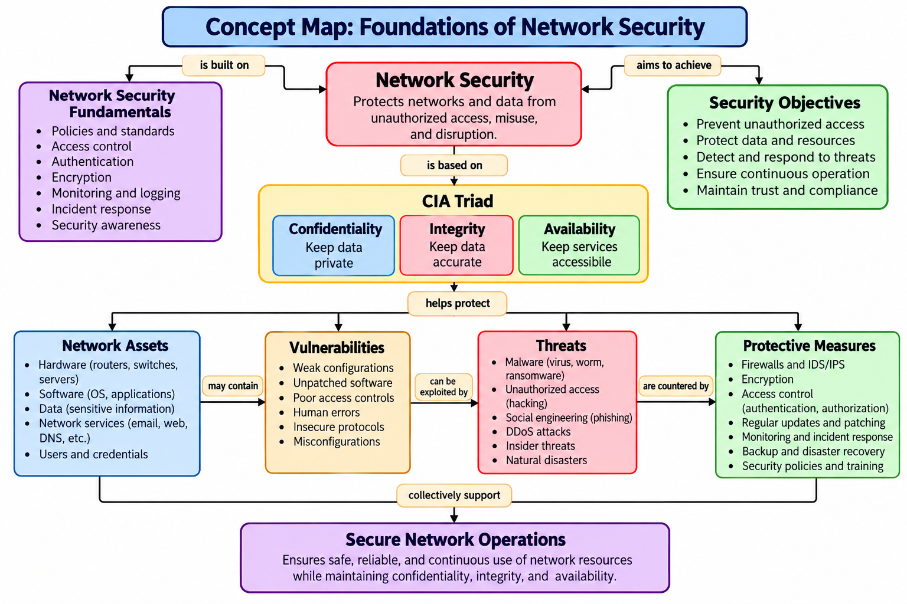

2 | Develop a concept map illustrating the CIA Triad as the foundation of network security. Relate Confidentiality, Integrity, and Availability to different types of network threats and demonstrate how a single threat can affect one or more security goals.
